*A project report on*

**STUDENT MANAGEMENT SYSTEM**

*Submitted in partial fulfillment for the award of the degree of*

**Integrated MTech (Software Engineering)**

*by*

**SEEGE REVATHI (17MIS7142)**



**AMARAVATI**

**SCHOOL OF COMPUTER SCIENCE AND ENGINEERING**

June 2019

**STUDENT MANAGEMENT SYSTEM**

*Submitted in partial fulfillment for the award of the degree of*

**Integrated MTech (Software Engineering)**

*by*

**SEEGE REVATHI (17MIS7142)**



**AMARAVATI**

**SCHOOL OF COMPUTER SCIENCE AND ENGINEERING**

June 2019

**CERTIFICATE**

This is to certify that the report entitled “STUDENT MANAGEMENT SYSTEM ” submitted by SEEGE REVATHI (17MIS7142) VIT-AP, for the award of the Summer Internship for the bonafide work carried out by her under my supervision.

The contents of this report have not been submitted and will not be submitted either in part or in full, for the award of any other degree or diploma in this institute or any other institute or university. The Project report fulfills the requirements and regulations of VIT-AP and in my opinion meets the necessary standards for submission.

**Signature of the Guide**

**ABSTRACT**

STUDENT MANAGEMENT SYSTEM (SMS) is a web-based application that tracks current student academic information. The proposed system SMS manages the information about students’ profile, courses, attendance, marks and Percentage. It also manages to keep all the records of students Performance and Progress.

User can access anywhere anytime to view their data . Student Management system is a Software which is helpful for Students as well as the Educational institutes . Our Student Management System deals with the various activities related to the students.

In the Software we can register as a user and user has of two types, student and administrator.

Administrator has the power to add new user and can edit and delete a user. A student can register as user and view their marks and printout the marks . The administrator can add edit and delete marks for the student as well as subjects and classes . All the users can see the marks.

There are mainly 2 modules in this software

* Admin module
* Student Module

**Admin** : This module is for admin to login and manage the application. After logging admin can get his Dashboard.Admin can add/update/ Class,Admin can add/update/ Subjects and Admin can add/update/ Active/Inactive Subject combination with class, Admin can register new student and also edit info of the student ,admin can declare/ edit  result of a student. Admin can change own password and logout

**Student :** In the student module the students can log in themselves using their register number along with their password. After logging in they can view records about them. The student can only view their records, they are not allowed to change the records. The student can also download the reports as a pdf file. It give information about the percentage of the student and record them.

**ACKNOWLEDGEMENT**

It is my pleasure to express with deep sense of gratitude to Dr. Aravapalli Rama Satish , Assistant Professor Sr Grade I, School of Computer Science and Engineering, VIT-AP, for his constant guidance, continual encouragement, understanding; more than all, he taught me patience in my endeavor. My association with him is not confined to academics only, but it is a great opportunity on my part of work with an intellectual and expert in the field of Computer Science and Engineering.

I would like to express my gratitude to Dr. G. Viswanathan, Chancellor, Mr. Shankar Viswanathan, VP, Dr. Khadambari S. Viswanathan, AVP, Dr. D. Subhakar, VC, and Dr. Hari Seetha, Dean, School of Engineering, for providing with an environment to work in and for his inspiration during the tenure of the course.

In jubilant mood I express ingeniously my whole-hearted thanks to Dr. Pradeep Reddy, Program Chair and Associate Professor, all teaching staff and members working as limbs of our university for their not-self-centered enthusiasm coupled with timely encouragements showed on me with zeal, which prompted the acquirement of the requirement of the requisite knowledge to finalize my course study successfully. I would like to thank my parents for their support.

It is indeed a pleasure to thank my friends who persuaded and encouraged me take up and complete this task. At last but not least, I express my gratitude and appreciation to all those who have helped me directly or indirectly toward the successful completion of this project.

Place: VIT-AP

Date**:** 27-06-2019 Name of the student

**S. REVATHI**

**CONTENTS**

CONTENTS----------------------------------------------------------------------IV

LIST OF FIGURES-----------------------------------------------------------**--VI**

LIST OF TABLES--------------------------------------------------------------VII

LIST OF ACROYNMS--------------------------------------------------------VIII

1. **Introduction**
   1. Project Overview---------------------------------------------------------1
   2. Project Description-------------------------------------------------------1
2. **Problem Definition**
   1. Existing System-----------------------------------------------------------3
   2. Disadvantages-------------------------------------------------------------3
   3. Proposed System----------------------------------------------------------3
   4. Advantages---------------------------------------------------------------- 3
3. **Feasibility Study**
   1. Technical Feasibility------------------------------------------------------4
   2. Economic Feasibility------------------------------------------------------5
   3. Operational Feasibility----------------------------------------------------5
4. **System Requirements**
   1. Software Requirements---------------------------------------------------6
   2. Hardware Requirements-------------------------------------------------- 6
   3. Languages Used----------------------------------------------------------- 6
5. **System Design**
   1. Data Flow Diagrams (DFD)--------------------------------------------11
   2. Unified Modeling Language (UML)----------------------------------14
   3. Entity Relationship Diagram--------------------------------------------21
   4. Database Tables-----------------------------------------------------------23
6. **Conclusion and Future Work**---------------------------------------------27
7. **Bibliography**------------------------------------------------------------------28
8. **Screens**-------------------------------------------------------------------------29

**LIST OF FIGURES**

Fig 1 Context Diagram-------------------------------------------------------------------------------12

Fig 2 1st Level DFD-----------------------------------------------------------------------------------13

Fig 3 2nd Level DFD----------------------------------------------------------------------------------14

Fig 4 Use Case Diagram------------------------------------------------------------------------------15

Fig 5 Class Diagram------------------------------------------------------------------------------------16

Fig 6 Admin Sequence Diagram----------------------------------------------------------------------17

Fig 7 Student Sequence Diagram--------------------------------------------------------------------18

Fig 8 Activity Diagram--------------------------------------------------------------------------------19

Fig 9 Admin Collaboration Diagram-----------------------------------------------------------------20

Fig 10 Student Collaboration Diagram----------------------------------------------------------------20

Fig 11 Entity Relationship Diagram-------------------------------------------------------------------22

**LIST OF TABLES**

Table 1 Admin Details--------------------------------------------------------------------------------23

Table 2 Student Details-------------------------------------------------------------------------------23

Table 3 Class Details --------------------------------------------------------------------------------24

Table 4 Subject Details------------------------------------------------------------------------------24

Table 5 Result Details-------------------------------------------------------------------------------25

Table 6 Subject combination Details --------------------------------------------------------------26

**DEFINITIONS, ACRONYMS & ABBREVIATIONS**

|  |  |
| --- | --- |
| CSS | **Cascading Style Sheet** |
| UML | Unified Modeling Language |
| WWW | World Wide Web |
| HTML | Hyper Text mark Language |
| PHP | Hypertext Preprocessor |
| SMS | Student Management System |
| JS | Java Script |
| SQL | Structured Query Language |

**Chapter 1**

**Introduction**

* 1. PROJECT OVERVIEW

This project is aimed at how the institute can improve the efficiency of the services. SMS is one of the applications to improve the information of any student. The system will store all the details of the students including their Educational Details ,Personal Details and all the information related to their Education .Checking a student details is very easy through this system So, this system is highly flexible one and is well efficient to make easy interactions with students and administrator .

1.2 PROJECT DESCRIPTION

STUDENT MANAGEMENT SYSTEM (SMS) is a web-based application that tracks current student academic information. The proposed system SMS manages the information about students’ profile, courses, attendance, marks and Percentage. It also manages to keep all the records of students Performance and Progress.

User can access anywhere anytime to view their data . Student Management system is a Software which is helpful for Students as well as the Educational institutes . Our Student Management System deals with the various activities related to the students.

In the Software we can register as a user and user has of two types, student and administrator.

Administrator has the power to add new user and can edit and delete a user. A student can register as user and view their marks and printout the marks . The administrator can add edit and delete marks for the student as well as subjects and classes . All the users can see the marks and printout them as a PDF format.

There are mainly 2 modules in this software

* Admin module
* Student Module

**Admin** : This module is for admin to login and manage the application. After logging admin can get his Dashboard.Admin can add/update/ Class,Admin can add/update/ Subjects and Admin can add/update/ Active/Inactive Subject combination with class, Admin can register new student and also edit info of the student ,admin can declare/ edit  result of a student. Admin can change own password and logout

**Student :** In the student module the students can log in themselves using their register number along with their password. After logging in they can view records about them. The student can only view their records, they are not allowed to change the records. The student can also download the reports as a pdf file. It give information about the percentage of the student and record them.

**Chapter 2**

**Problem Definition**

2.1 EXISTING SYSTEM

The Existing System for Student Management System is very manual ,requiring a lot of human resource and paperwork .starting from a new student admission, course details ,classes, marks and percentage everything done manually.so there is a lot of risk and time consuming .So we can easily get the unnecessary details

2.2 PROBLEMS IN EXISTING SYSTEM

All the details of the student are maintained in a single record .It requires a lot of laborious work. So, searching and upgrading the details is tedious task. System is time-consuming and there is a chance of getting inefficient results. The entire Process of this system is done manually.

2.3 PROPOSED SYSTEM

STUDENT MANAGEMENT SYSTEM (SMS) is a web-based application that tracks current student academic information. The proposed system SMS manages the information about students’ profile, courses, attendance, marks and Percentage. It also manages to keep all the records of students Performance and Progress.

User can access anywhere anytime to view their data . Student Management system is a Software which is helpful for Students as well as the Educational institutes . Our Student Management System deals with the various activities related to the students. We can easily access any student’s information anytime and can be kept for long period of time without any damage.

2.4 ADVANTAGES

By developing the system, we can attain the following features :

It provides “better and efficient” service.

Reduce the workload of an institute.

We can get information about the students in a fast way .

Provide facility for proper monitoring ,reduce paperwork and provide security for the data

**Chapter 3**

**Feasibility Study**

Preliminary investigation examine project feasibility, the likelihood the system will be useful to the organization. The main objective of the feasibility study is to test the Technical, Operational and Economical feasibility for adding new modules and debugging old running system. All system is feasible if they are unlimited resources and infinite time. There are aspects in the feasibility study portion of the preliminary investigation:

* Technical Feasibility
* Operation Feasibility
* Economical Feasibility

3.1 TECHNICAL FEASIBILITY

The technical issue usually raised during the feasibility stage of the investigation includes

* Does the necessary technology exist to do what is suggested?
* Does the proposed equipment have the technical capacity to hold the data required to use the new system?
* Will the proposed system provide adequate response to inquiries, regardless of the number or location of users?
* Can the system be upgraded if developed?
* Are there technical guarantees of accuracy, reliability, ease of access and data security?

Earlier no system existed to cater to the needs of ‘Secure Infrastructure Implementation System’. The current system developed is technically feasible. It is a web-based user interface. Thus, it provides an easy access to the users. The database’s purpose is to create, establish and maintain a workflow among various entities in order to facilitate all concerned users in their various capacities or roles. Permission to the users would be granted based on the roles specified. Therefore, it provides the technical guarantee of accuracy, reliability and security. The software and hard requirements for the development of this project are not many and are available as free as open source. The work for the project is done with the current equipment and existing software technology. Necessary bandwidth exists for providing a fast feedback to the users irrespective of the number of users using the system.

3.2 ECONOMIC FEASIBILITY

A system can be developed technically and that will be used if installed must still be a good investment for the organization. In the economical feasibility, the development cost in creating the system is evaluated against the ultimate benefit derived from the new systems. Financial benefits must equal or exceed the costs. The system is economically feasible. It does not require any addition hardware or software. Since the interface for this system is developed using the existing resources and technologies available. There is nominal expenditure and economical feasibility for certain.

3.3 OPERATIONAL FEASIBILITY

Proposed projects are beneficial only if they can be turned out into information system. That will meet the organization’s operating requirements. Operational feasibility aspects of the project are to be taken as an important part of the project implementation. Some of the important issues raised are to test the operational feasibility of a project includes the following: -

* Is there sufficient support for the management from the users?
* Will the system be used and work properly if it is being developed and implemented?
* Will there be any resistance from the user that will undermine the possible application benefits?

This system is targeted to be in accordance with the above-mentioned issues. Beforehand, the management issues and user requirements have been taken into consideration. So, there is no question of resistance from the users that can undermine the possible application benefits.

The well-planned design would ensure the optimal utilization of the computer resources and would help in the improvement of performance status.

**Chapter 4**

**System Requirements**

4.1 SOFTWARE REQUIREMENTS

|  |  |
| --- | --- |
| Operating System | Windows 10 |
| Web Technologies | HTML, JavaScript, CSS |
| Web Server | PHP |
| Database | MySQL |
| Software | XAMPP for PHP & MySQL |

4.2 HARDWARE REQUIREMENTS

|  |  |
| --- | --- |
| Processor | Intel Corei5 or More |
| RAM | 2GB RAM |
| Hard Disk | PC with 40GB |

4.3 LANGUAGES USED:

In this project, we chose PHP and HTML language for developing the code PHP (recursive acronym for PHP: Hypertext Preprocessor) is a widely used open source general-purpose scripting language that is especially suited for web development and can be embedded into HTML.

* PHP is a recursive acronym for "PHP: Hypertext Preprocessor".
* PHP is a server-side scripting language that is embedded in HTML. It is used to manage dynamic content, databases, session tracking, even build entire e-commerce sites.
* It is integrated with a number of popular databases, including MySQL, PostgreSQL, Oracle, Sybase, Informix, and Microsoft SQL Server.
* PHP is pleasingly zippy in its execution, especially when compiled as an Apache module on the Unix side. The MySQL server, once started, executes even very complex queries with huge result sets in record-setting time.
* PHP supports a large number of major protocols such as POP3, IMAP, and LDAP. PHP4 added support for Java and distributed object architectures (COM and CORBA), making n-tier development a possibility for the first time.
* PHP language tries to be as forgiving as possible

Advantages of PHP :

* Open source: It is developed and maintained by a large group of PHP developers, this will help in creating a support community, abundant extension library.
* Speed: It is relative fast since it uses much system resource.
* Easy to use: It uses C like syntax, so for those who are familiar with C, it’s very easy for them to pick up and it is very easy to create website scripts.
* Stable: Since it is maintained by many developers, so when bugs are found, it can be quickly fixed.
* Powerful library support: You can easily find functional modules you need such as PDF, Graph etc.
* Built-in database connection modules: You can connect to database easily using PHP, since many websites are data/content driven, so we will use database frequently, this will largely reduce the development time of web apps.
* Can be run on many platforms, including Windows, Linux and Mac, it’s easy for users to find hosting service providers.

Java Script :

JavaScript is a dynamic computer programming language. It is lightweight and most commonly used as a part of web pages, whose implementations allow client-side script to interact with the user and make dynamic pages. It is an interpreted programming language with object-oriented capabilities.

Advantages of Java Script :

The biggest advantages to a JavaScript having a ability to produce the same result on all modern browsers.

Client-Side execution: No matter where you host JavaScript, execute always on client environment to save a bandwidth and make execution process fast.

User Interface Interactivity: JavaScript used to fill web page data dynamically such as drop-down list for a Country and State. Base on selected Country, State drop down list dynamically filled. Another one is Form validation, missing/incorrect fields you can alert to a user’s using alert box.

Rapid Development: JavaScript syntaxes are easy and flexible for the developers. JavaScript small bit of code you can test easily on Console Panel (inside Developer Tools) at a time browser interpret return output result. In-short easy language to get pick up in development.

Browser Compatible: The biggest advantages to a JavaScript having a ability to support all modern browser and produce the same result.

HTML:

HTML, which stands for Hypertext Markup Language, is the predominant markup language for web pages. It provides a means to create structured documents by denoting structural semantics for text such as headings, paragraphs, lists, links, quotes and other items. It allows images and object to be embedded and can be used to create interactive forms. It is written in the form of HTML elements consisting of “tags” surrounded by angle brackets within the web page content. It can embed scripts in languages such as JavaScript which affect the behavior of HTML web pages. HTML can also be used to include Cascading Style Sheets (CSS) to define the appearance and layout of text and other material. The W3C, maintainer of both HTML and CSS standards, encourages the use of CSS over explicit presentational markup.

Advantages of HTML:

* First advantage is that it is widely used, easy to learn and use.
* Every browser supports HTML language.
* HTML also allows the use of templates, which makes designing a webpage easy.
* It is default in every window, so you don’t need to purchase extra software.

CSS:

**C**ascading **S**tyle **S**heets, fondly referred to as CSS, is a simple design language intended to simplify the process of making web pages presentable.CSS handles the look and feel part of a web page. Using CSS, you can control the color of the text, the style of fonts, the spacing between paragraphs, how columns are sized and laid out, what background images or colors are used, layout designs, variations in display for different devices and screen sizes as well as a variety of other effects.

Advantages of CSS**:**

* Easier to maintain and update
* Greater consistency in design
* More formatting options
* Lightweight code
* Faster download times
* Search engine optimization benefits
* Ease of presenting different styles to different viewers
* Greater accessibility

MySQL:

MySQL is the most popular Open Source Relational SQL Database Management System. MySQL is one of the best RDBMS being used for developing various web-based software applications. MySQL is developed, marketed and supported by MySQL , which is a Swedish company. This tutorial will give you a quick start to MySQL and make you comfortable with MySQL programming.

Advantages of MySQL:

* Data Security: MySQL is globally renowned for being the most secure and reliable database
* On-Demand Scalability. MySQL offers unmatched scalability to facilitate the management
* High Performance: MySQL features a distinct storage-engine framework.
* Round-the-clock Uptime:MySQL comes with the assurance.

**Chapter 5**

**System Design**

5.1 DATA FLOW DIAGRAMS

A data flow diagram is graphical tool used to describe and analyze movement of data through a system. These are the central tool and the basis from which the other components are developed. The transformation of data from input to output, through processed, may be described logically and independently of physical components associated with the system. These are known as the logical data flow diagrams.

The development of DFD’S is done in several levels. Each process in lower level diagrams can be broken down into a more detailed DFD in the next level. The lop-level diagram is often called context diagram. It consists a single process bit, which plays vital role in studying the current system. The process in the context level diagram is exploded into other process at the first level DFD

DATA FLOW DIAGRAMS

CONTEXT DIAGRAM

High level Entities and process flow of SMS

* Managing all the Marks
* Managing all the Attendance
* Managing all the Students
* Managing all the Faculties
* Managing all the Grades

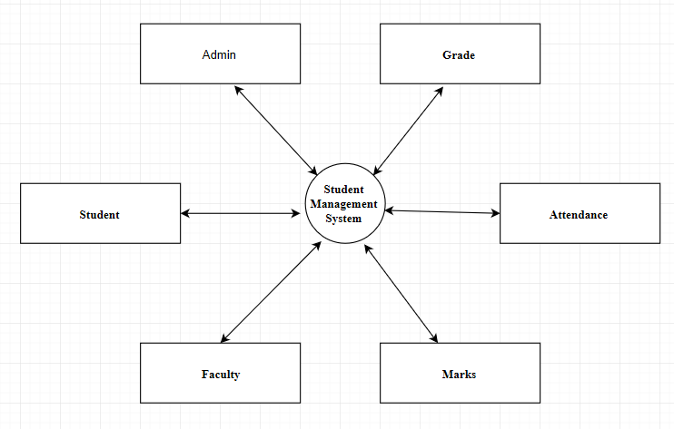

1st Level DFD’s

Main Entities and output of First Level DFD

* Processing Admin records and generate report of Admin
* Processing Marks records and generate report of Marks
* Processing Students records and generate report of Students
* Processing Faculties records and generate report of Faculties
* Processing Attendance records and generate report of Attendance
* Processing Grades records and generate report of Grades
* Processing Semester records and generate report of Semester

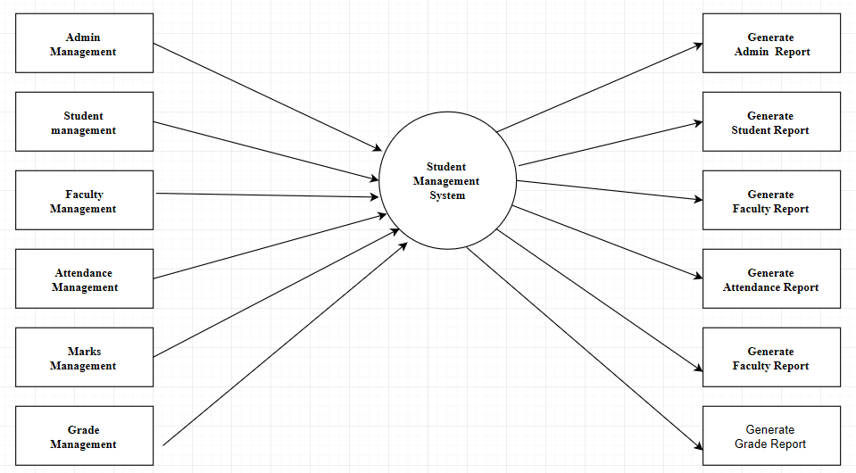

2nd Level DFD’s

Low level functionalities of SMS

* Admin logins to the system and manage all the functionalities of student management
* Admin can add, edit, delete, and view the records of Students, Courses, Semester
* Admin can manage all the details of classes, faculties, Registrations
* Admin can also generate reports of classes, Students, Faculties, Courses, and Marks
* Admin can search the details of Student marks and courses
* Admin can apply different level of filters on report of Faculties, courses
* Admin can track the detailed information of classes, students, faculties, courses

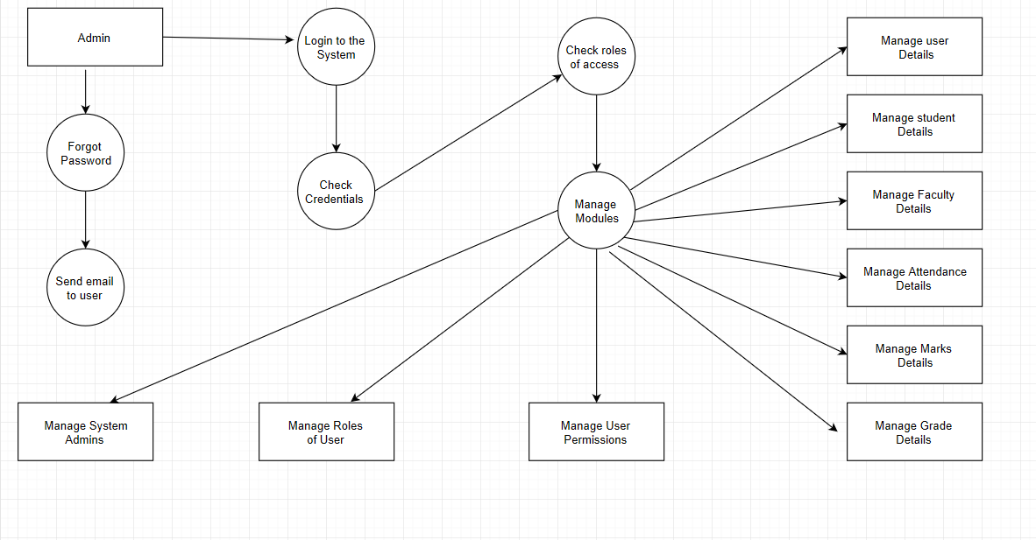

5.2 UML DIAGRAMS

The unified modeling language allows the software engineer to express an analysis model using the modeling notation that is governed by a set of syntactic semantic and pragmatic rules.

UML is specifically constructed through two different domains they are

* UML Analysis modeling, which focuses on the user model and structural model views of the system.
* UML design modeling, which focuses on the behavioral modeling, implementation modeling and environmental model views.

5.2.1 USE-CASE DIAGRAMS:

Use case Diagrams represent the functionality of the system from a user’s point of view. Use cases are used during requirements elicitation and analysis to represent the functionality of the system.

Use cases focus on the behavior of the system from external point of view. Actors are external entities that interact with the system. Examples of actors include users like administrator, Student or another system like central database.

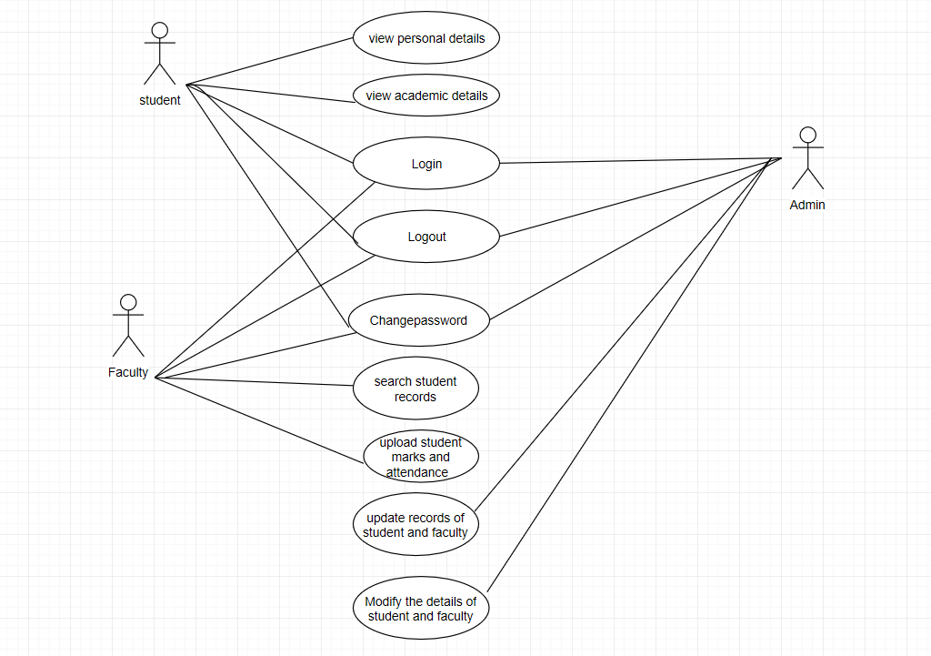

Fig : Use-Case Diagram

5.2.2 CLASS DIAGRAMS:

The class diagram is used to define a detailed design of the system. It classifies the actors into a set of interrelated classes. The relationship or association between the classes can be either an “is-a” or “has-a” relationship. Each class in the class diagram may be capable of providing certain functionalities. These functionalities provided by the class are termed as “methods” of the class. Apart from this, each class may have certain “attributes” that uniquely identify the class.

The class diagram shows how the different entities (people, things, and data) relate to each other in other words, it shows the static structures of the system. A class is depicted on the class diagram as a rectangle with three horizontal sections. The upper section shows the class's name; the middle section contains the class's attributes; and the lower section contains the class's operations (or "methods").

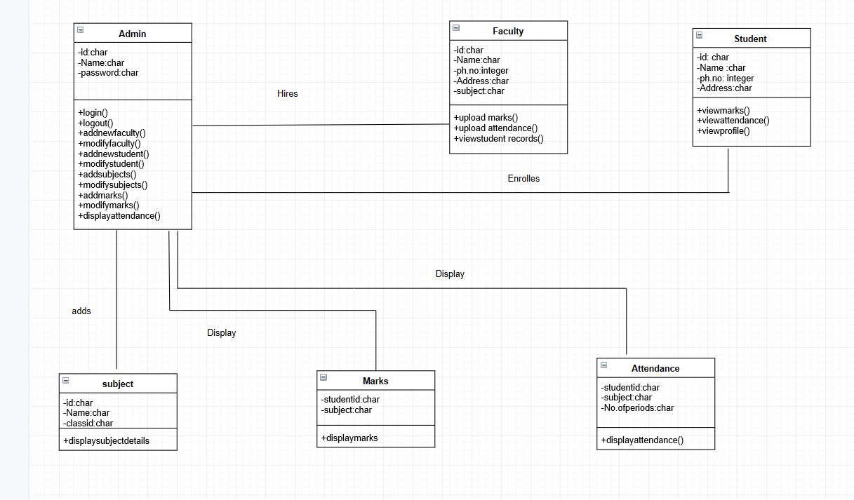

Fig : Class Diagram

5.2.3 SEQUENCE DIAGRAMS:

A sequence diagram represents the interaction between different objects in the system. The important aspect of a sequence diagram is that it is time-ordered. This means that the exact sequence of the interactions between the objects is represented step by step. Different objects in the sequence diagram interact with each other by passing “messages”.

Sequence Diagrams Represent the objects participating the interaction horizontally and time vertically. A sequence diagram has two dimensions: The vertical dimension shows the sequence of messages/calls in the time order that they occur; the horizontal dimension shows the object instances to which the messages are sent.

For Administrator



Fig : Sequence Diagram for Admin

For student



Fig : Sequence Diagram for Student

5.2.4 ACTIVITY DIAGRAM:

The process flows in the system are captured in the activity diagram. Similar to a state diagram, an activity diagram also consists of activities, actions, transitions, initial and final states, and guard conditions.

We use **Activity Diagrams** to illustrate the flow of control in a system and refer to the steps involved in the execution of a use case. We model sequential and concurrent activities using activity diagrams. So, we basically depict workflows visually using an activity diagram. An activity diagram focuses on condition of flow and the sequence in which it happen

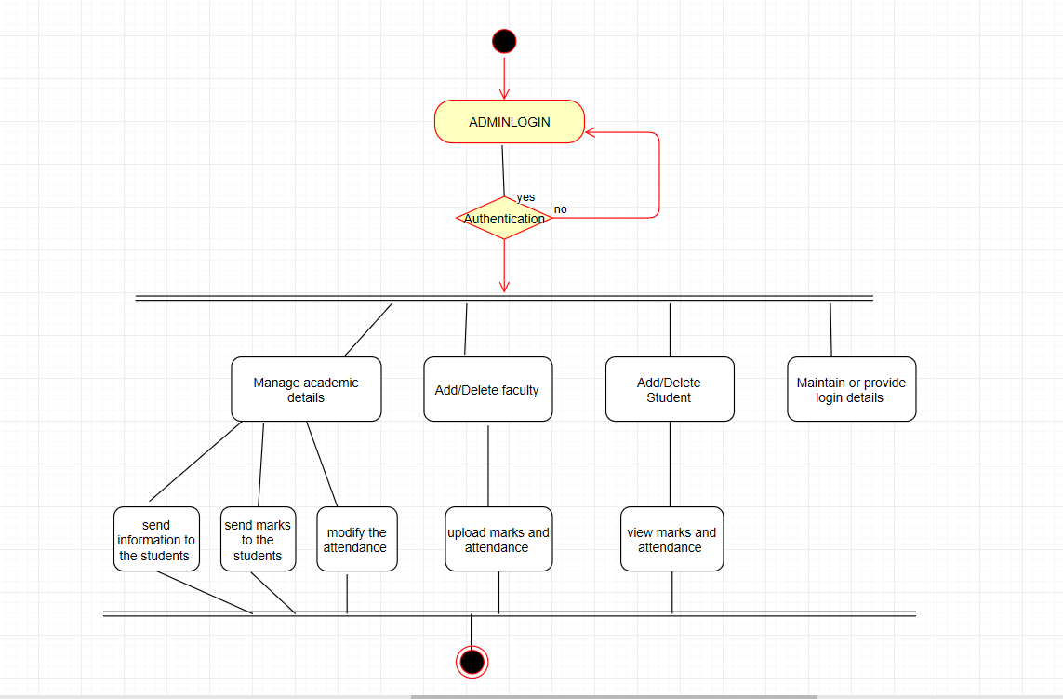

Fig : Activity Diagram

5.2.5 COLLABORATION DIAGRAM:

Collaboration diagrams also known as communication diagrams are used to show how objects interact to perform the behavior of a particular use case, or a part of a use case. Along with sequence diagrams, collaboration are used by designers to define and clarify the roles of the objects that perform a particular flow of events of a use case. They are the primary source of information used to determining class responsibilities and interfaces

When creating collaboration diagrams, patterns are used to justify relationships. Patterns are best principles for assigning responsibilities to objects and are described further in the section on patterns. There are two main types of patterns used for assigning responsibilities which are **evaluative** patterns and **driving** patterns.

Each system operation initiates a collaboration diagram. Therefore, there is a collaboration diagram for every system operation

For Administrator



For Student

s

5.3 Entity Relationship Diagram

The relation upon the system is structure through a conceptual ER-Diagram, which not only specifics the existential entities but also the standard relations through which the system exists and the cardinalities that are necessary for the system state to continue. The entity Relationship Diagram (ERD) depicts the relationship between the data objects. The ERD is the notation that is used to conduct the date modeling activity the attributes of each data object noted is the ERD can be described resign a data object description.

The set of primary components that are identified by the ERD are

* Data object
* Relationships
* Attributes
* Various types of indicators.

This ER diagram represents the model of Student management system Entity. This ER diagram of SMS shows all the visual instrument of database tables and the relations between students, marks, attendance and grade etc. It used structure data and to define the relationships between structured data groups of SMS functionalities .The main entities of the Student management system are Students, faculties, courses and Admin.

Description of Student Management System Database **:**

* The details of Students are store into the student’s tables respective with all tables.
* Each entity (Admin, courses, students, )contains primary key and unique keys.
* There is one-to-one and one-to-many relationships available between courses, faculties, Admin ,Students

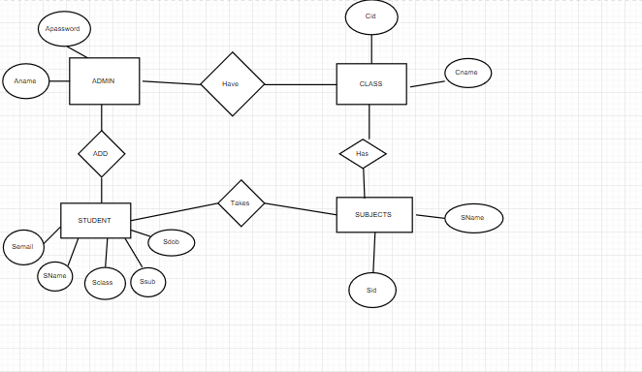

Entity Relationship Diagram

5.4 Database Tables

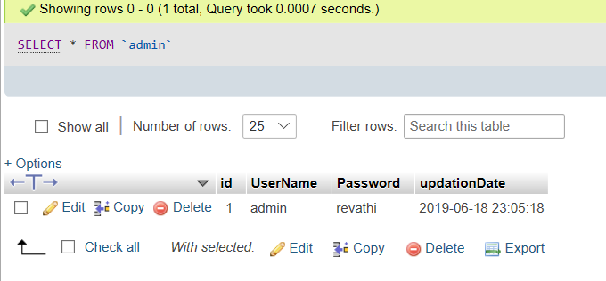

Table 1: Database Table for storing Admin Details

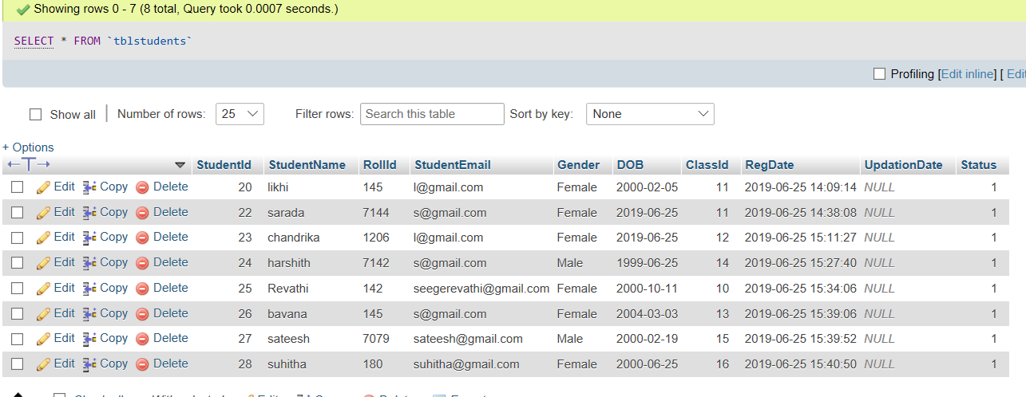

Table 2 : Database Table for storing Student Details

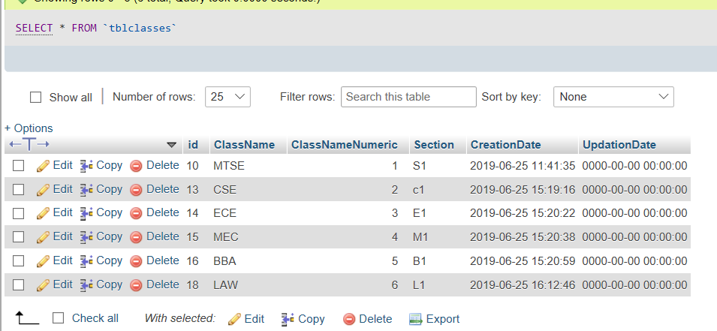

Table 3 : Database Table for storing Class Details

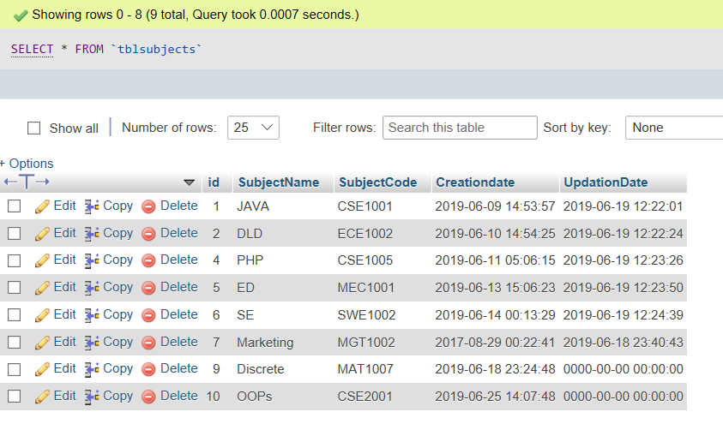

Table 4 : Database Table for storing Subjects Details

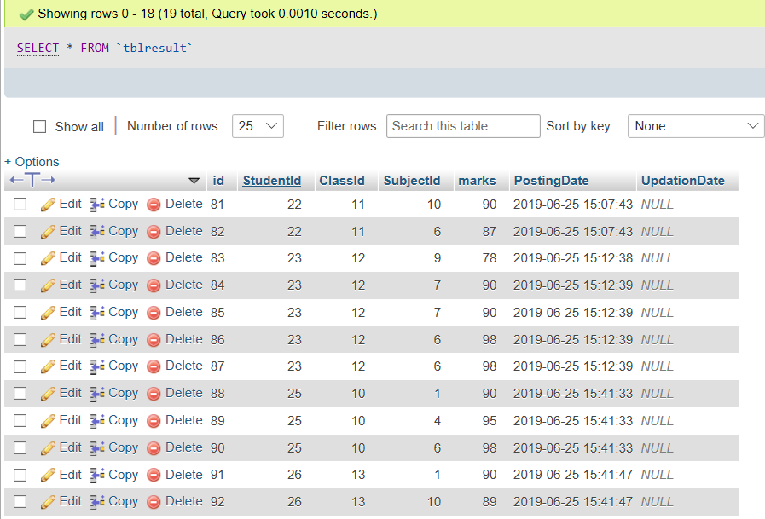

Table 5 : Database Table for storing Result Details

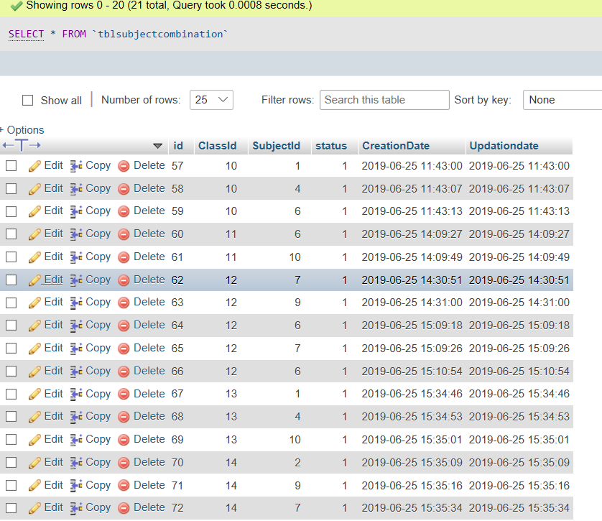

Table 6 : Database Table for storing Subject combination Details

**Chapter 6**

**CONCLUSION AND FUTURE WORK**

It has been a great pleasure for me to work on this exciting and challenging project. This project proved good for me as it provided practical knowledge of not only programming in PHP web Technology but also in MySQL Server, but also about all handling procedure related with **“Student Management System”.** It also provides knowledge about the latest technology used in developing web enabled application and client server technology that will be great demand in future. This will provide better opportunities and guidance in future in developing projects independently. This Software is very easy to use so all educational institutes can use this frequently .So we can hope that our software will be very popular and get sponsors to develop in Future .

In the Future the Students can also be able to upload or download notes .we can credit and CGPA of students. The whole project will be made available as an Android APP for easier of use and mobility

**Chapter 7**

**Bibliography**

REFERENCES

[1]. Anandi Sharma, (2012) JavaScript and HTML DOM Reference Retrieved from <https://www.tutorialspoint.com/html_online_training>

[2]. Cerami, E. (2002). *Web services essentials: distributed applications with XML-RPC, SOAP, UDDI & WSDL*. " O'Reilly Media, Inc.".

[3] MacDonald, M. (2012). *WordPress: the missing manual*. " O'Reilly Media, Inc.".

[4] Welling, L., & Thomson, L. (2003). PHP and MySQL Web development. Sams Publishing.

[5]. Atkinson, Leon. Core PHP Programming: Using PHP to Build Dynamic Web Sites, Second Edition. Upper Saddle River, NJ: Prentice Hall PTR, 2001.

**Chapter 8**

**Screen Shots**

Homepage for Administrator

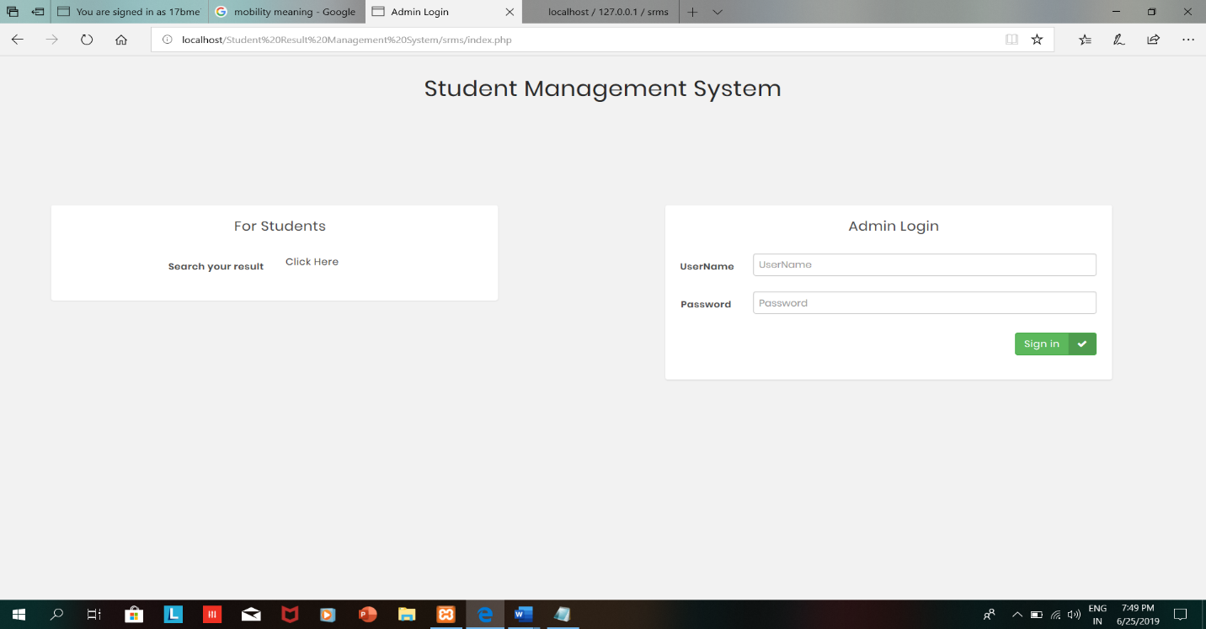

After logging with credentials , The Admin can view his/her activities

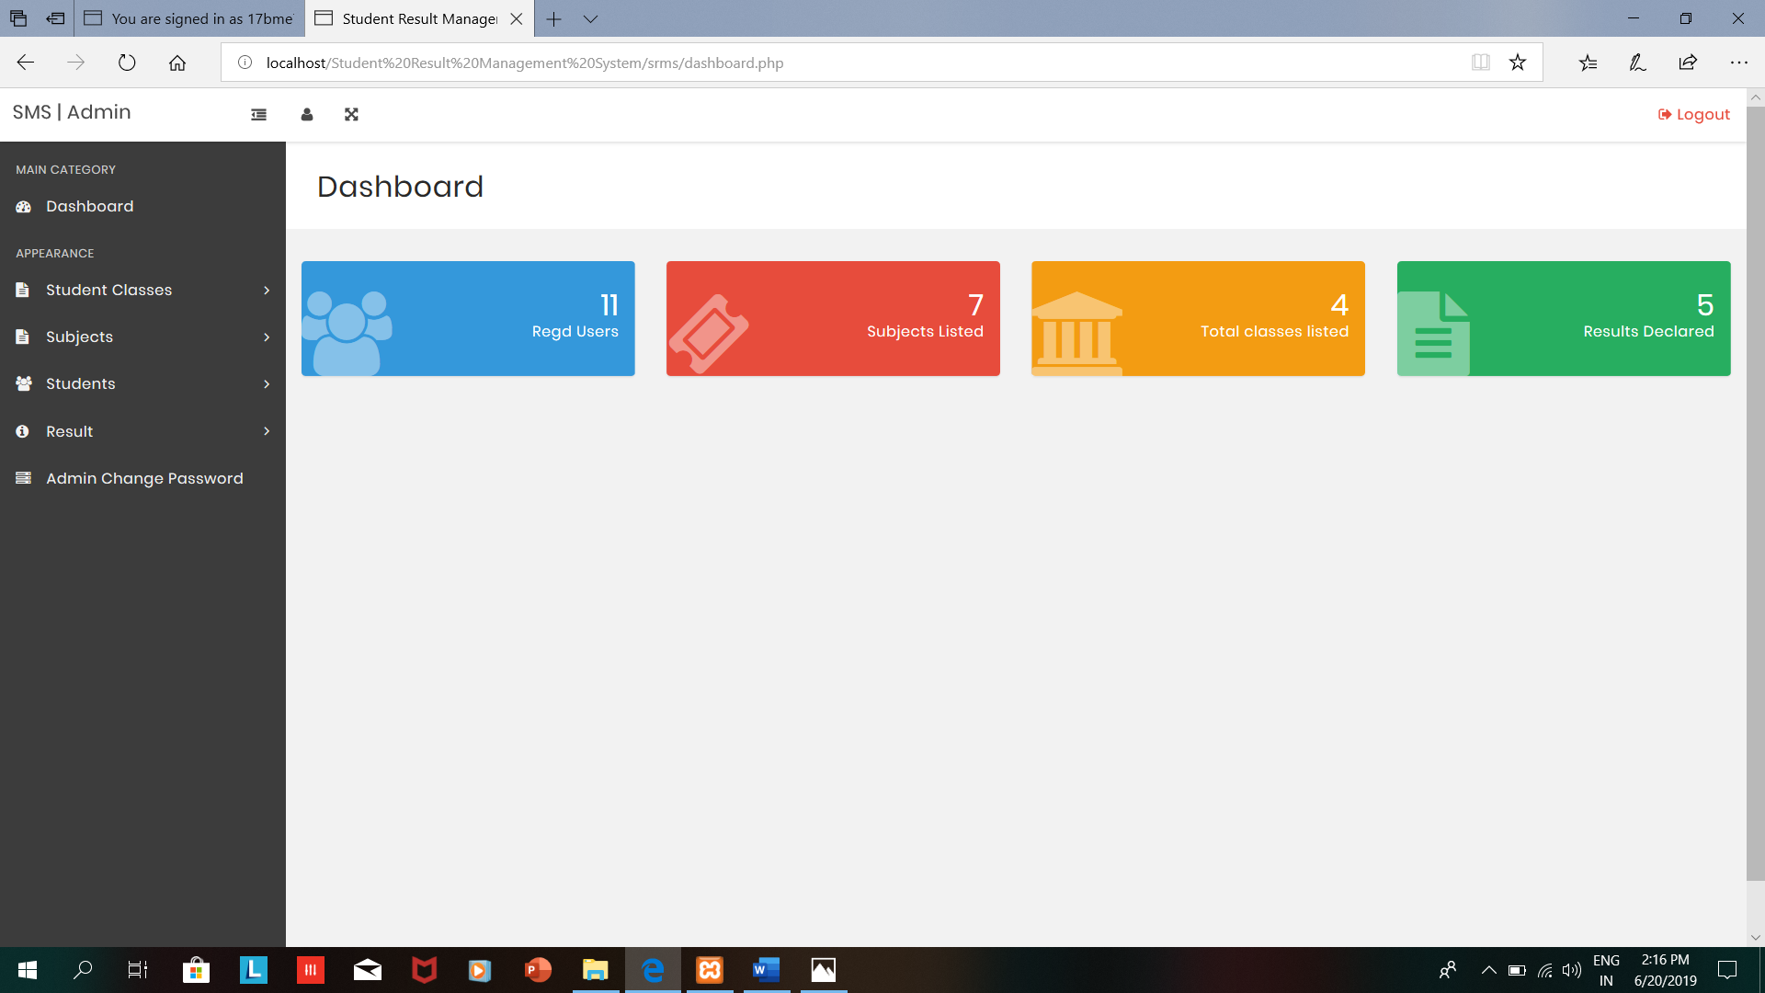

Admin can create classes for the students

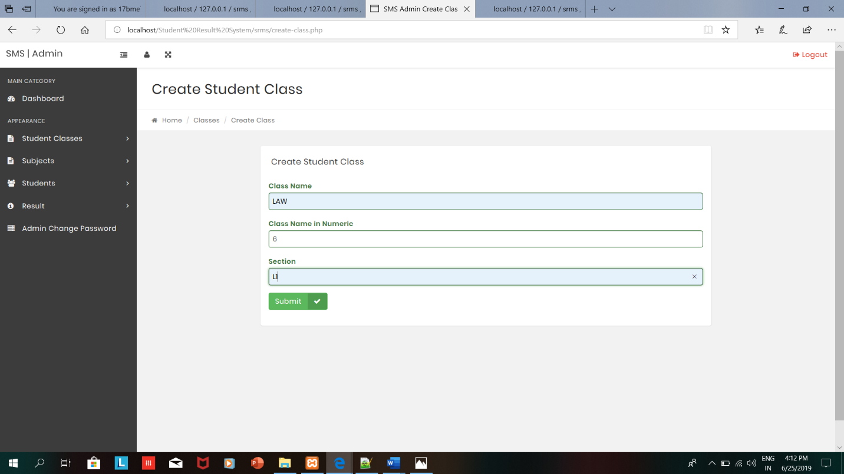

After creating the class , admin can get the below message

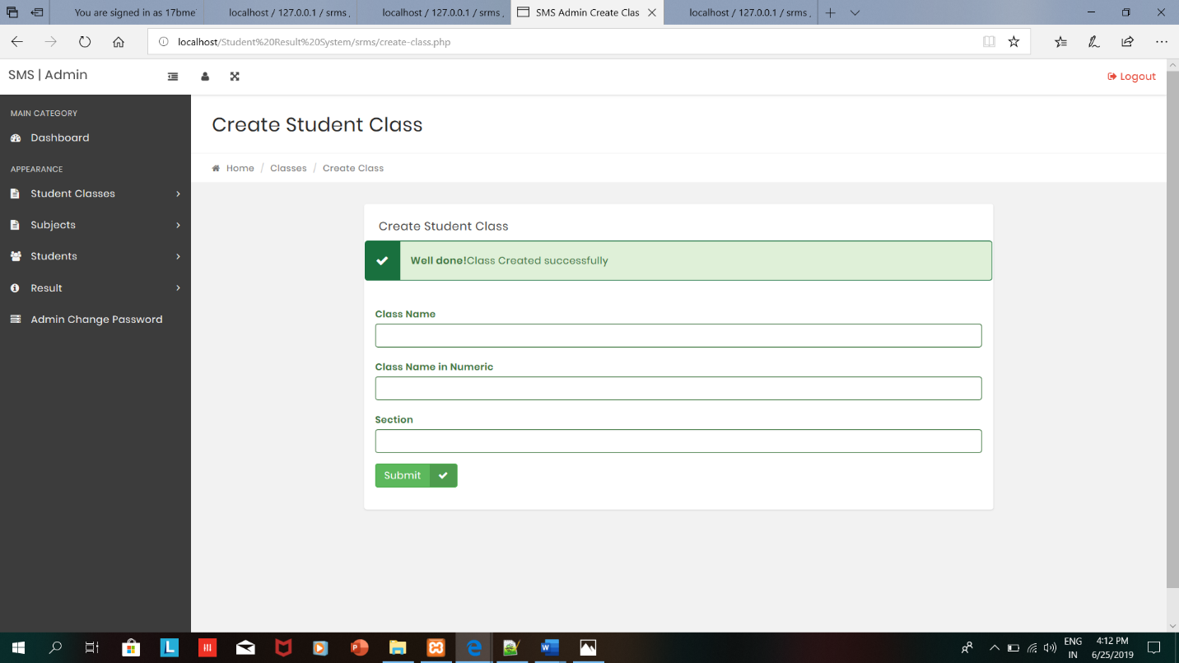

Admin can manage classes

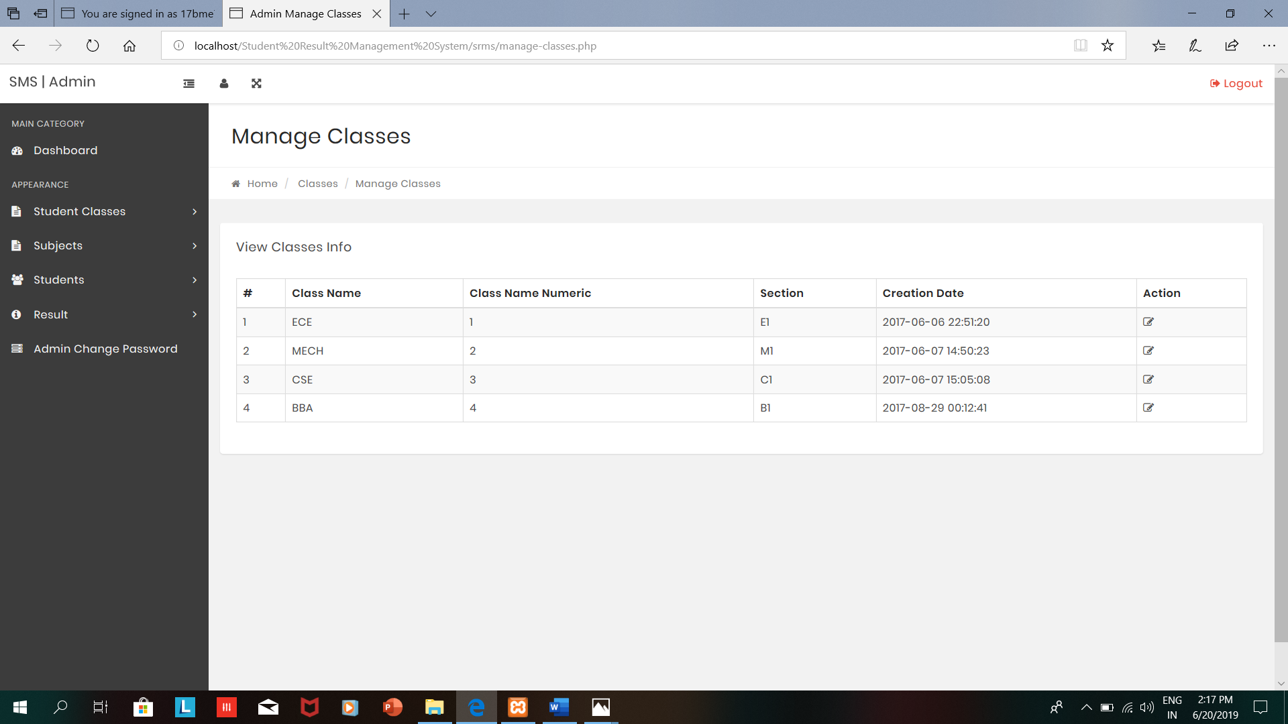

Admin can create the subjects

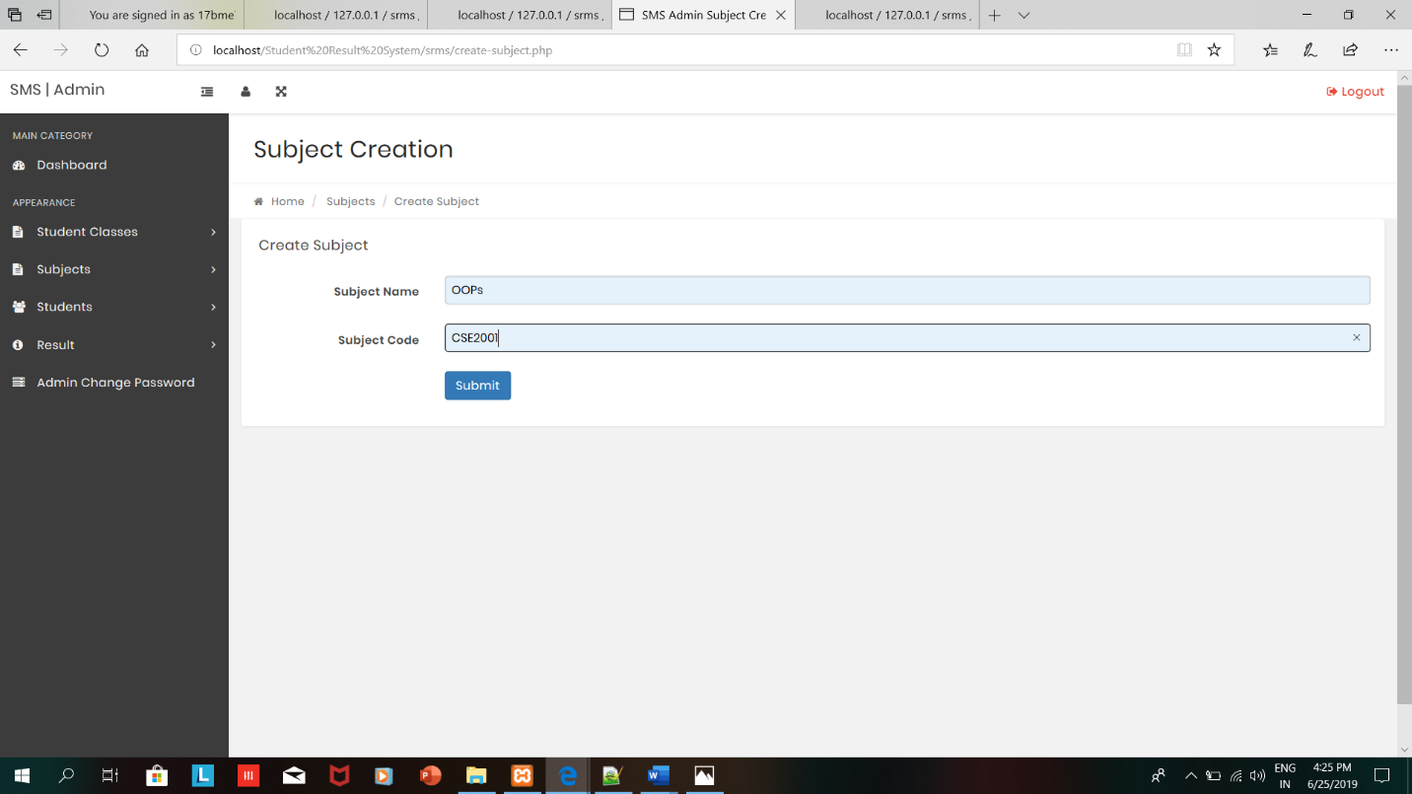

After creating the Subject ,admin can get the below message

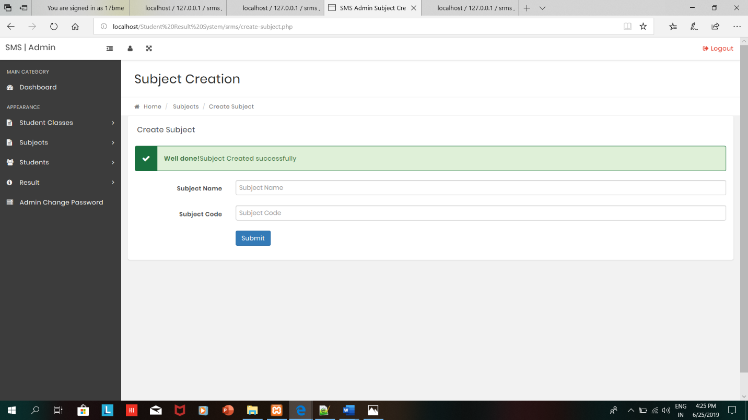

Admin can manage the subjects

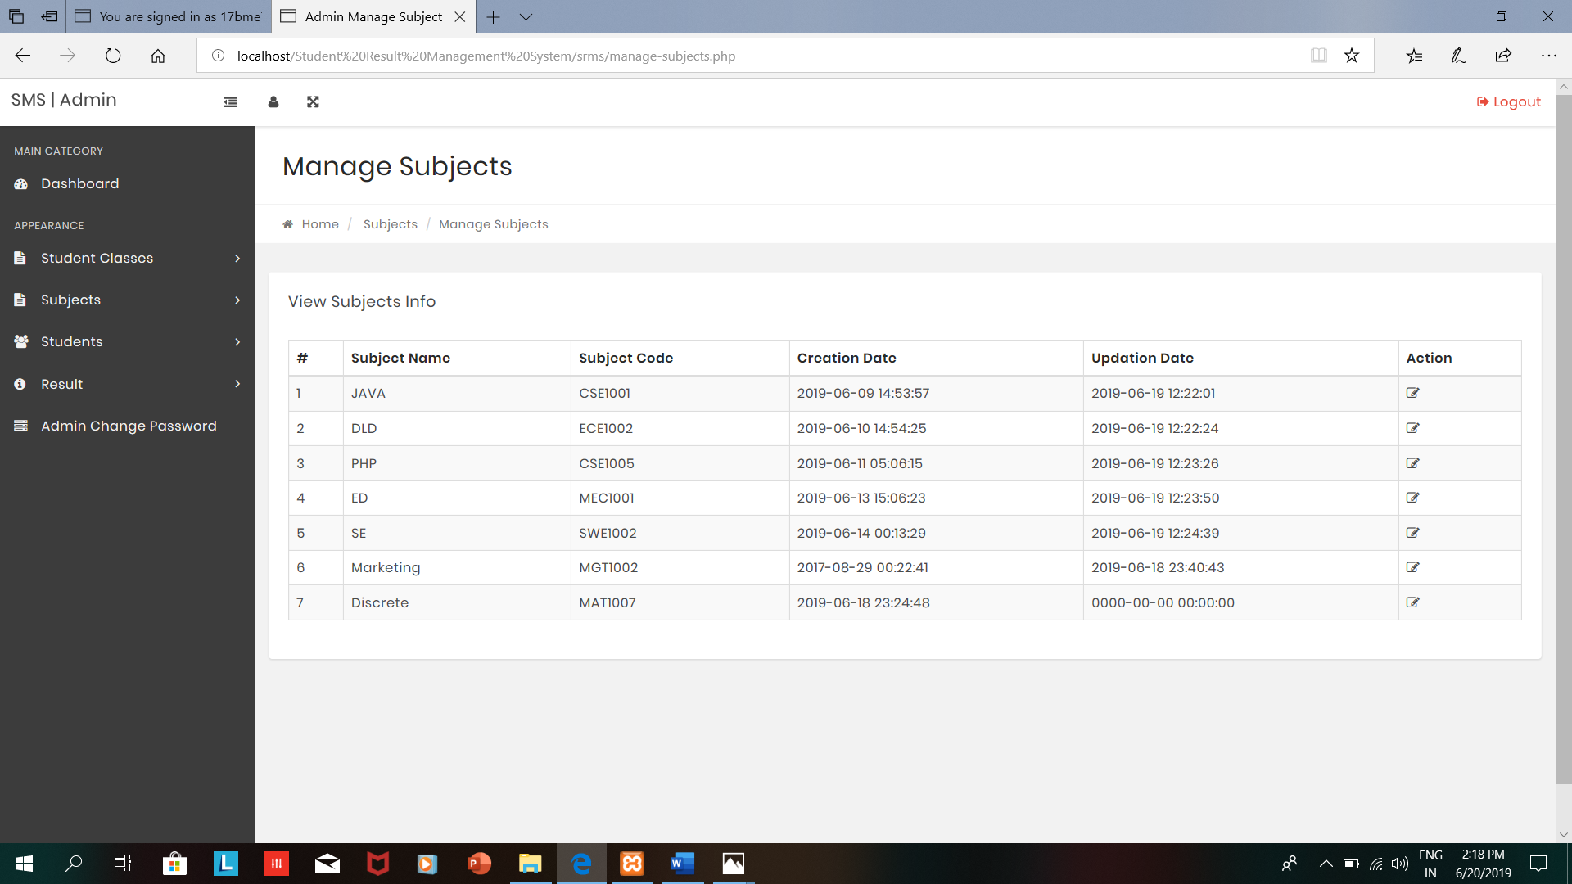

Admin can add the subject combination

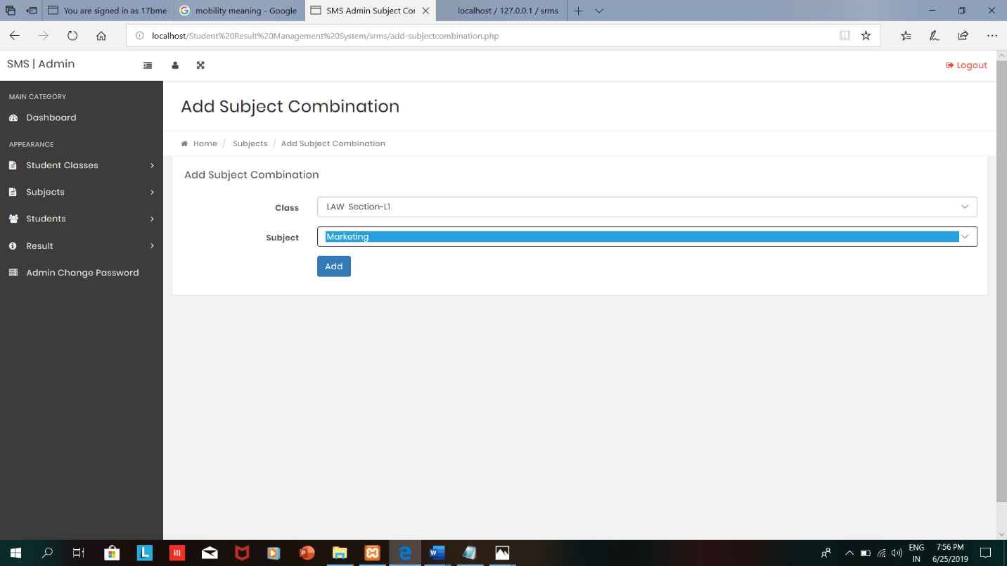

After adding Subject combination ,the admin can view the below message

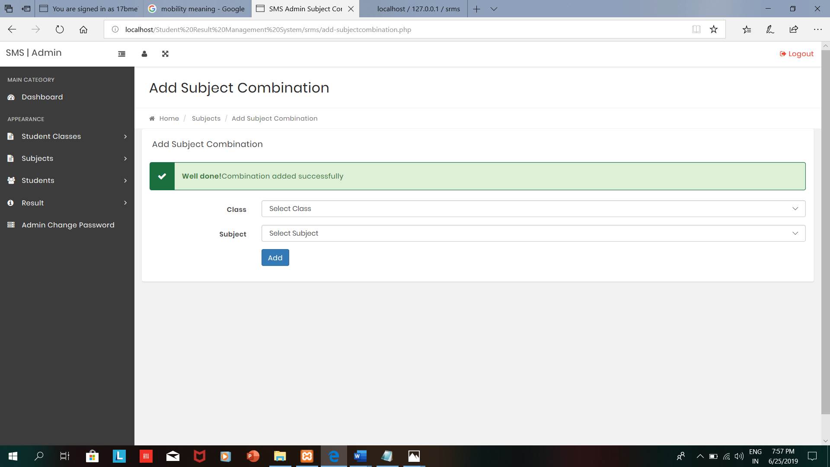

Admin can manage the subject combinations

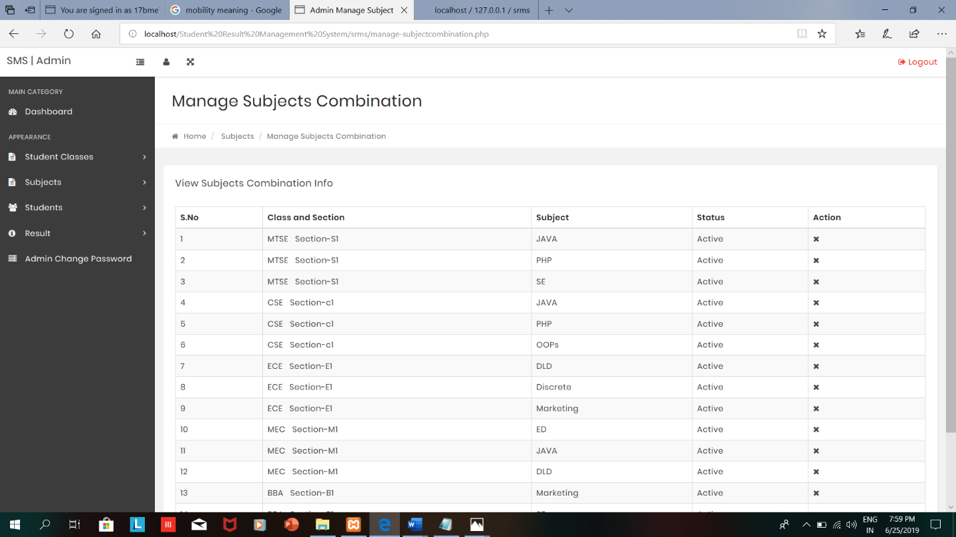

Admin can give admission to the student

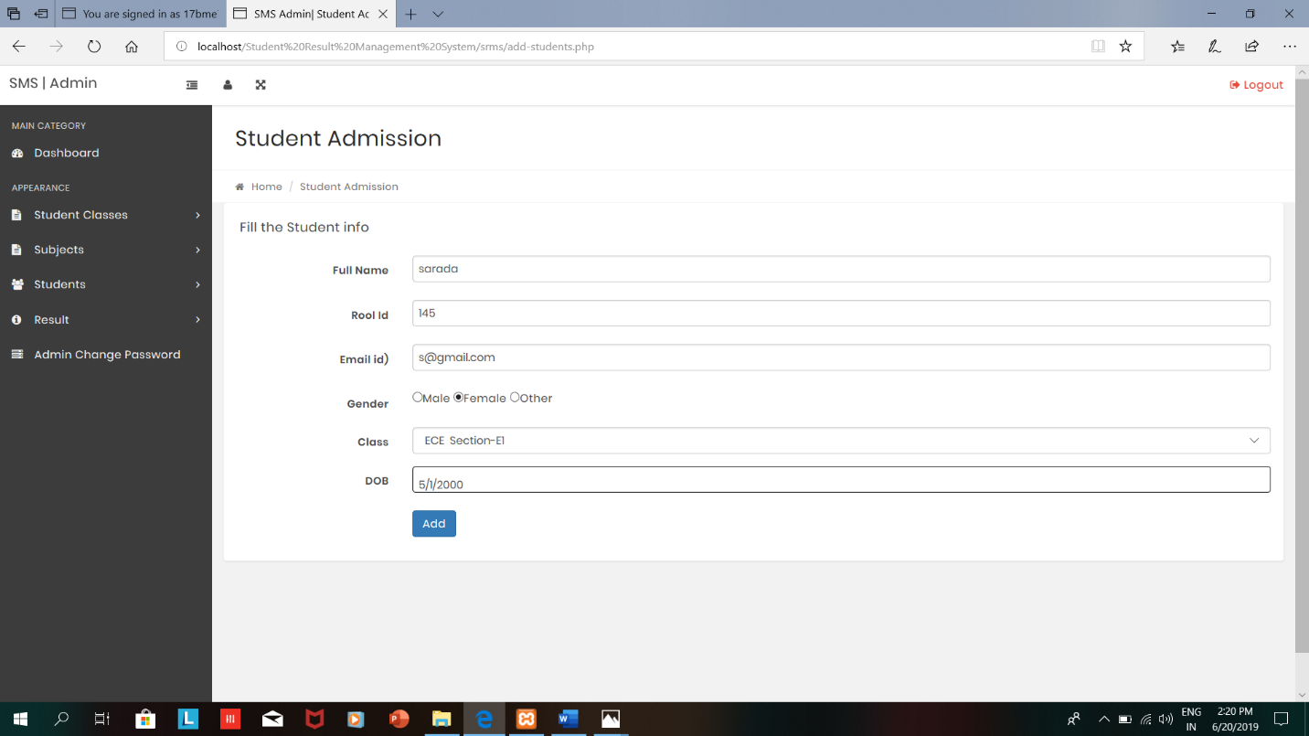

After giving the admission to the student ,admin can view the below message

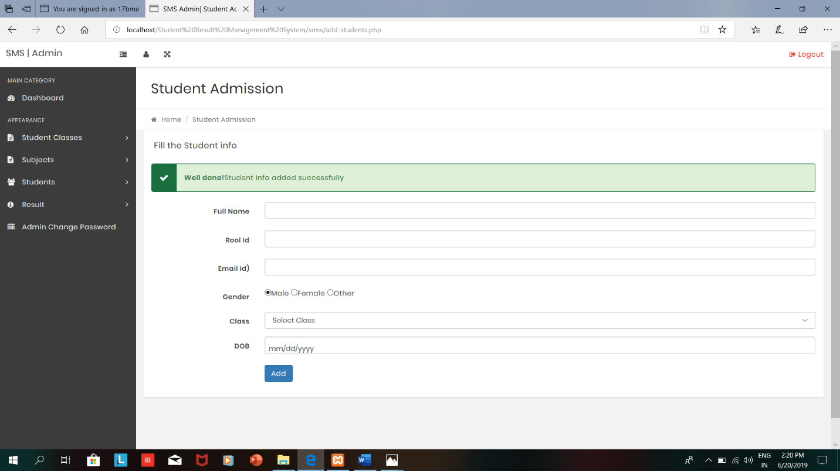

Admin can manage the students

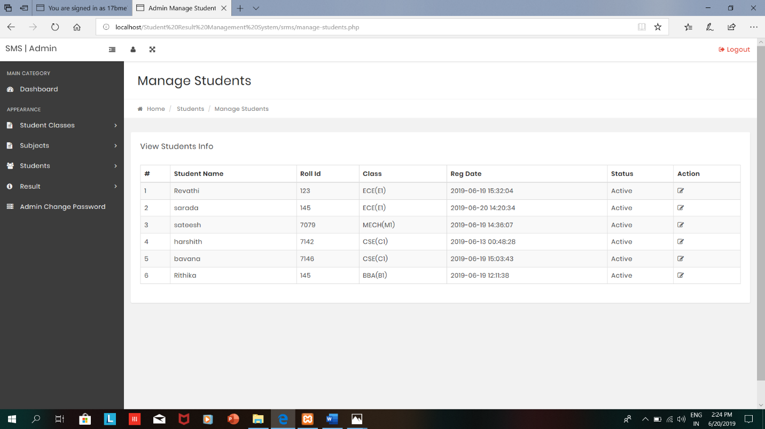

Admin can add result

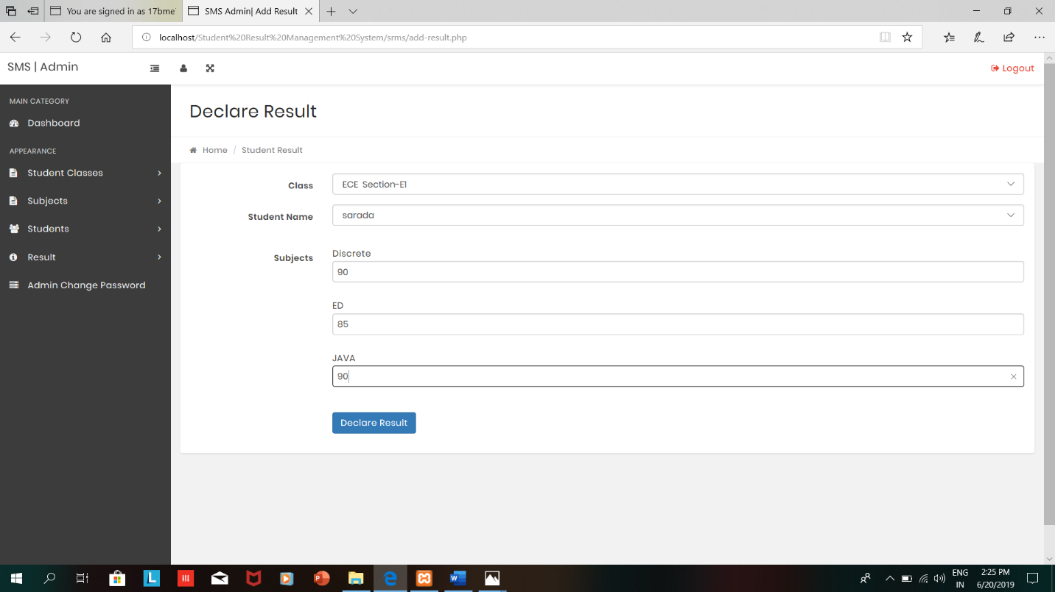

Admin can update the Result Info

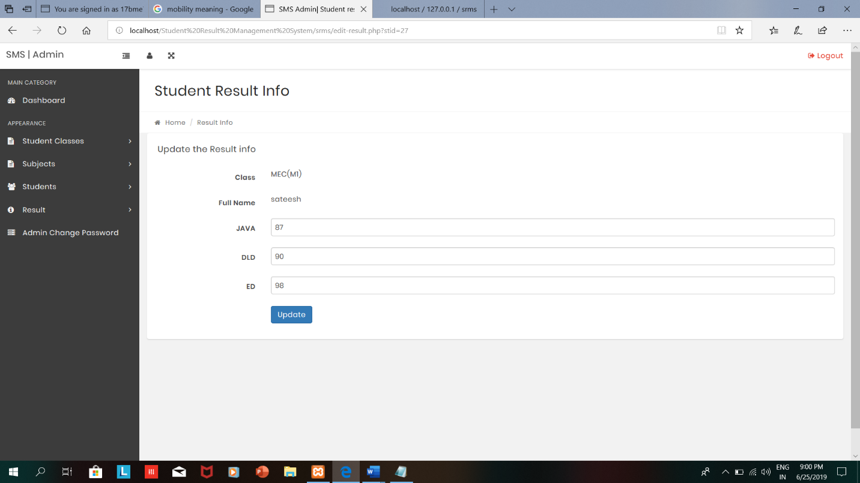

After updating the results,admin can view the below message

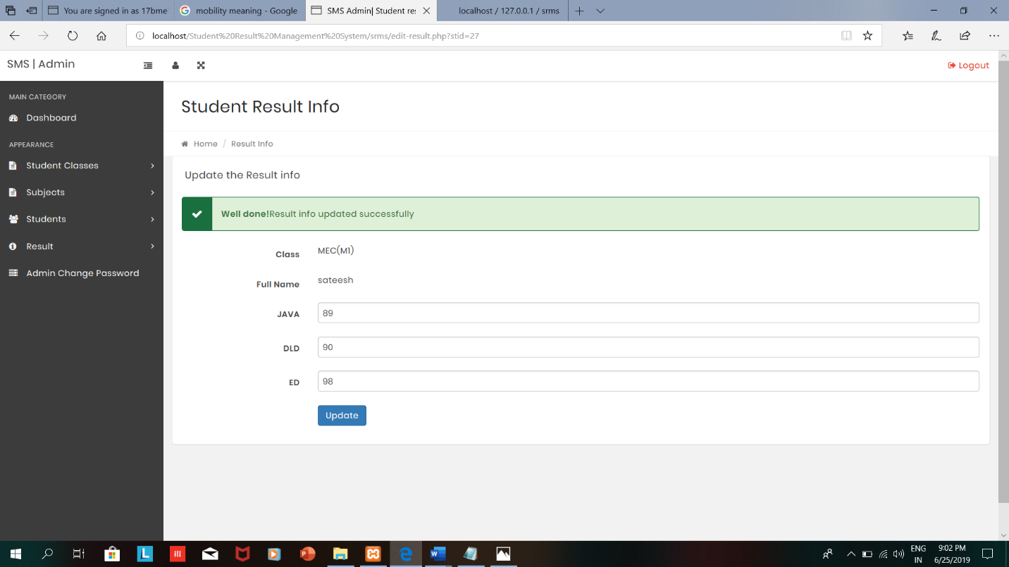

Admin can change password and logout

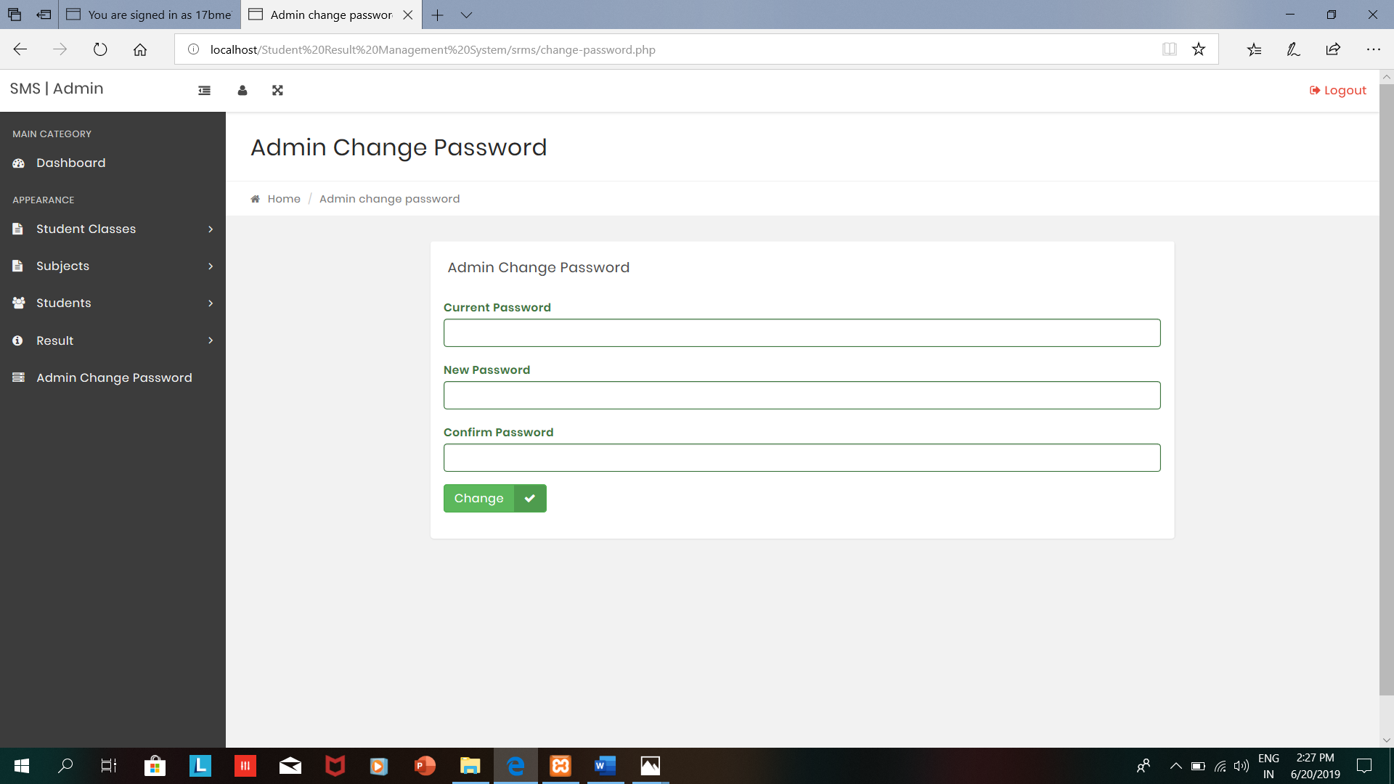

Homepage for student



Student can enter their roll id and class to view their results

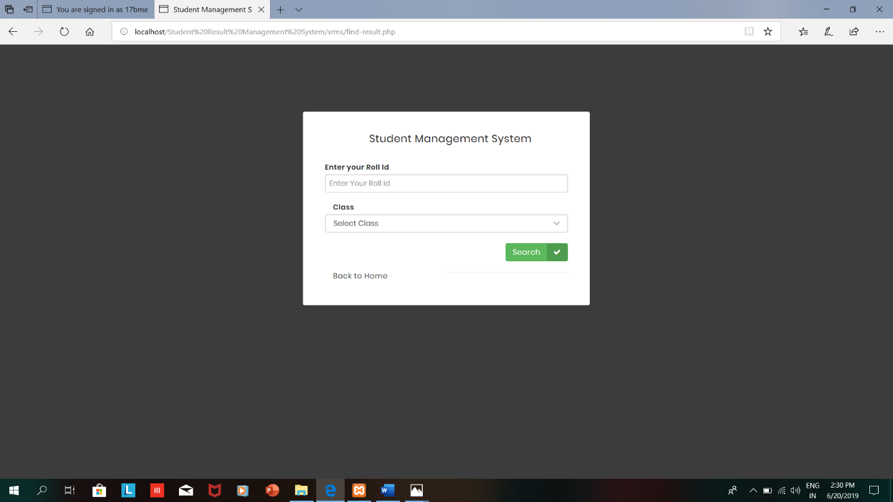

After entering the details student can view his/her results

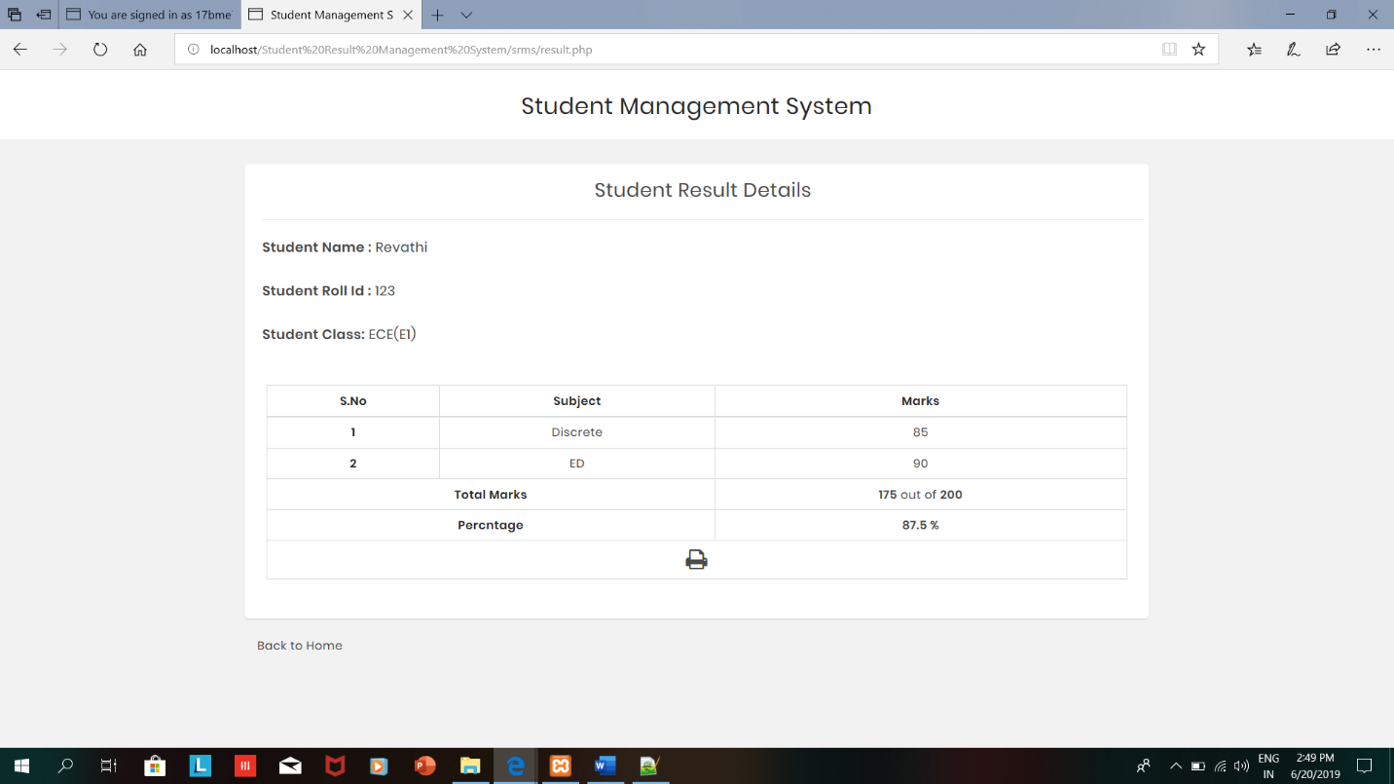

After viewing the results, student can print the results as a pdf format if she/he wants

